Non-Breakseal bubbler

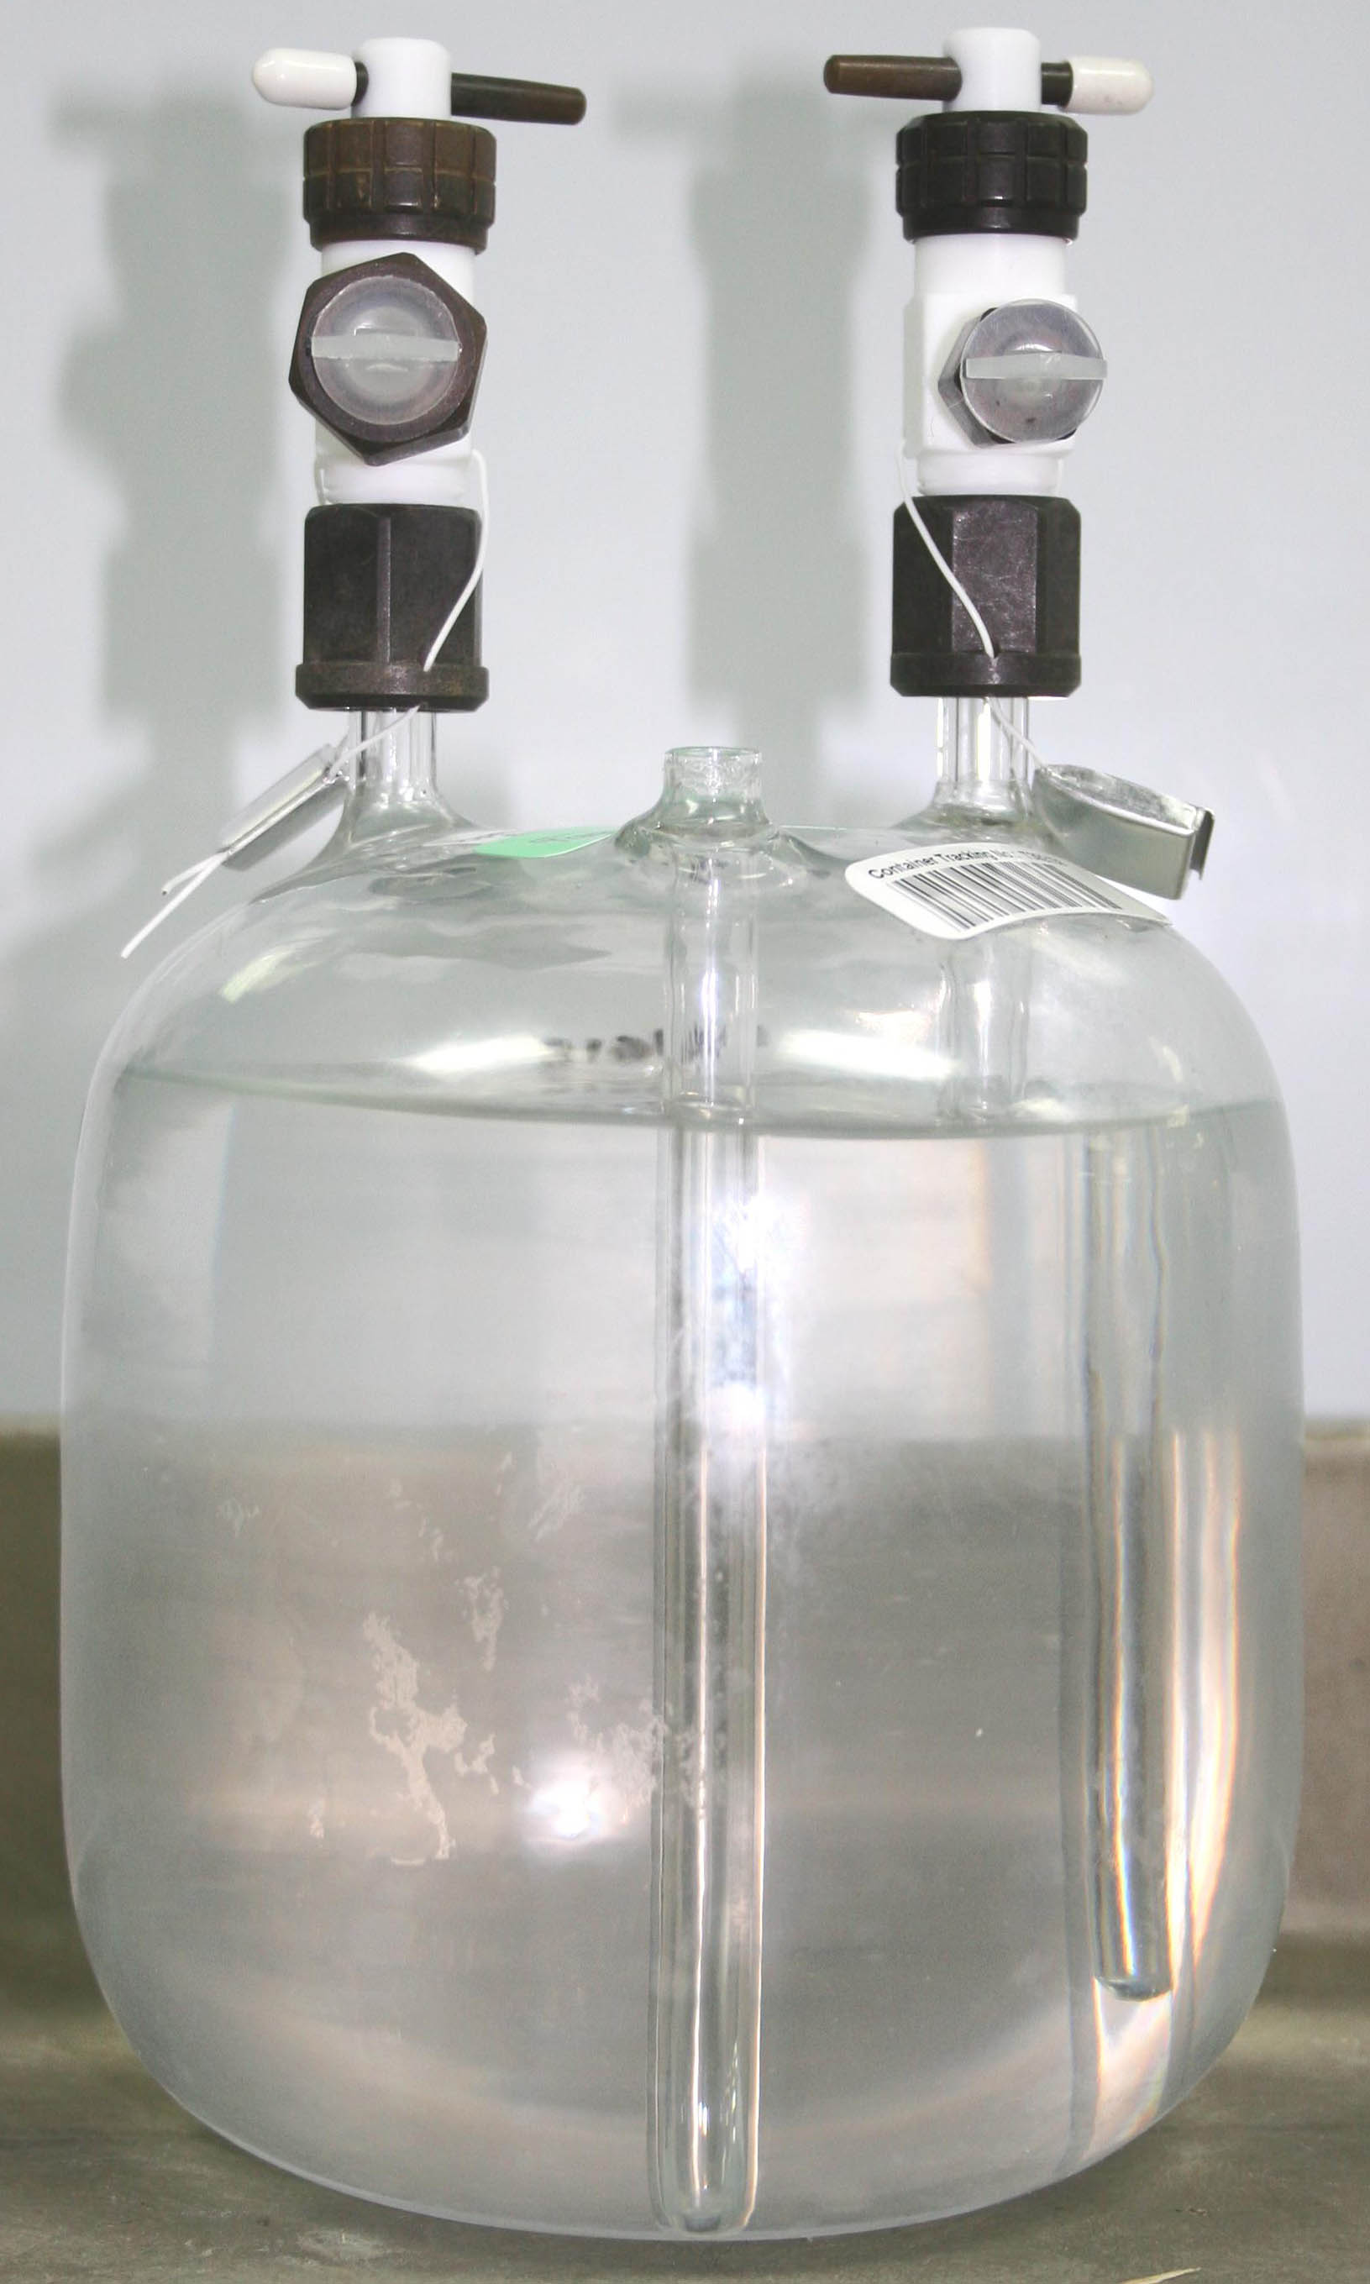
Tamper evident wire clamp
The only physical difference between a nonbreakseal bubbler and a breakseal bubbler is a breakseal bubbler has a fill stem

White Caps on valves for No-Breakseal bubblers. Green caps on valves for Breakseal bubblers

Hexagon mounting nut
Tamper evident wire -
Teflon coated wire
C-Valve – 6mm/1/4”
D-Valve – 10mm/3/8”

